Washoe Local Emergency Planning Committee

General Membership Meeting

**Minutes**

**Thursday ~ August 28, 2014 ~ 9:00 A.M.**

**REGIONAL EMERGENCY OPERATIONS CENTER**

**5195 SPECTRUM BOULEVARD, RENO, NEVADA 89512**

**1. CALL TO ORDER AND ROLL CALL** - (Non-action item)

Chair Kenneston called the meeting to order at 9:07 a.m. A quorum was established.

**PRESENT:** Gary Beekman – Washoe County Technology Services; Lance Boekenoogen – Nevada Air National Guard, NVCERFP; Steve Burlie – Regional Transportation Commission; Chris Cenac – Truckee Meadows Water Authority; Michelle Gitmed – Reno Police Department; Rob Kelley – Community Resources Department; Aaron Kenneston – Washoe County Emergency Management; Alex Kukulus – Sparks Fire Department; Spencer Lewis – University of Nevada, Reno; Patrick Macan – American Red Cross; Chris Magenheimer – North Lake Tahoe Fire Protection District; Casey Micone – Reno Tahoe Airport Authority; Tom Nelson – Reno Tahoe Airport Authority; Mitch Nowicki – Regional Emergency medical Services Authority; Tim O’Conner – Washoe County Sheriff’s Office; Don Pelt – Pyramid Lake Paiute Tribe; Suzy Rogers – Reno Emergency Communications Center; Kevin Schaller – University of Nevada, Reno; Edwin Smith – Washoe County Health District; Tim Spencer – Reno Fire Department; Shannon Wiecking – Reno Police Department; Jeff Whitesides – Washoe County Health District; and Jim Wilson – Reno Sparks Convention and Visitors Authority. Richard Gammick – Washoe County District Attorney, joined the meeting at 9:12 a.m.

**ABSENT:** Scott Alquist – Truckee Meadows Community College; Julie Bender – Regional Public Safety Training Center; Kelly Boyd – American Red Cross; Mike Brown – North Lake Tahoe Fire Protection District; Darryl Cleveland – Truckee Meadows Community College; Christina Conti – Washoe County Health District; Diane Drinkwater – Washoe County District Attorney’s Office; Skip Eller – Reno Sparks Convention and Visitors Authority; Jason Elorza – Sparks Fire Department; James English – Washoe County Health District; Jim Gubbels – Regional Emergency Medical Services Authority; Jim Hadsall – Reno Sparks Convention and Visitors Authority; Pat Hambright – KOLO, Channel 8; Nida Harjo – Reno Sparks Indian Colony; Anna Heenan – Washoe County Health District; John Helzer – Washoe County District Attorney’s Office; Bruce Hicks – North Lake Tahoe Fire Protection District; Timothy Hill – Nevada Air National Guard; David Hunkup – Reno Sparks Indian Colony; Logan Ingersoll – Nevada Air National Guard; Andy Koski – Sparks Fire Department; Mike Krysztof – Truckee Meadows Fire Protection District; Beth Langan – Regional Public Safety Training Center; Chad Leonard – University of Nevada, Reno; Tim Leighton – Truckee Meadows Fire Protection District; Chris Long – Washoe County Technology Services; Teresa Long – Washoe County Health District; Chris Maples – Sparks Fire Department; Matt Marquez – Sparks Police Department; Ian McEwen – Nevada Air National Guard, NVCERFP; Rob McLaughlin – Veterans Administration Hospital; Kenneth Miller – Pyramid Lake Paiute Tribe; Eric Millette – Sparks Fire Department; Michael Munda – Renown; Joe Nishikida – Reno Fire Department; Brad Norman – Truckee Meadows Community College; Tim O’Brien – Reno Fire Department; Debbie Penrod – University of Nevada, Reno; Jerry Preston – Community Services Department; Phil Povey – Truckee Meadows Community College; Jim Reagan – NV Energy; Rob Reeder – Regional Transportation Commission; Brian Reeder – Associated General Contractors; Josh Reynolds – Truckee Meadows Community College; Al Rogers – Washoe County Management Services; Bob Sack – Washoe County Health District; Frank Schumann – Washoe County Sheriff’s Office; Eric Stringer – Nevada Air National Guard, NVCERFP; Brian Taylor – Regional Emergency Medical Services Authority; Pat Thomas – KOLO, Channel 8; Jim Wilson – Reno Sparks Convention and Visitors Authority; and Dominica Yturbide – Reno Emergency Communications Center.

Blaine Cartlidge – Deputy District Attorney, was also present.

**2. APPROVAL OF MINUTES** (For possible action) – *May 22, 2014 Grants and Finance Subcommittee and June 19, 2014 General Membership meeting minutes.*

Hearing no public comments, Chair Kenneston asked for board discussion or a motion.

***It was moved by Kevin Schaller, seconded by Jeff Whitesides, to approve the May 22, 2014 Grants and Finance Subcommittee minutes as written.***

Dick Gammick – Washoe County District Attorney, joined the meeting at 9:12 a.m.

***It was moved by Michelle Gitmed, seconded by Kevin Schaller, to approve the June 19, 2014, General Membership minutes, as submitted. MOTION CARRIED.***

**3. PUBLIC COMMENTS** (Non-action item)

Chair Kenneston recognized Chris Magenheimer who will be retiring later today, August 28, 2014. Mr. Kenneston noted that Mr. Magenheimer had been among the first to receive a Master’s Degree in Homeland Security and had acted as a Division Chief representing Emergency Preparedness. Chair Kenneston presented Mr. Magenheimer with an Eagle statue for his dedication and service.

Mr. Magenheimer expressed his appreciation.

Dee Grimm joined the meeting via teleconference at 9:15 a.m.

**4. TREASURER’S REPORT** (For possible action) – *A review, discussion and possible action to accept Revenue and Payables reports.*

Cathy Ludwig – Grants Coordinator, provided an overview of the 2014 SERC (State Emergency Response Commission) grants which ended June 30, 2014. Ms. Ludwig explained that other grants are part of this particular grant cycle and will be finalized in the next quarter. Ms. Ludwig noted that of the FY 14 SERC UWS (United We Stand) all but $1,269.47 had been expended and the FY 14 SERC grant had expended all but $1,229.40. Chris Curatilo of ERRG is present to discuss the Strategic Plan update later in the agenda; that grant ends September 30, 2014. Ms. Ludwig noted that the HMEP (Hazardous Materials Emergency Preparedness) grant of $17,113.00 had spent $7,570.04 with $9,542.96 being deobligated. Ms. Ludwig then turned to the 2015 SERC grant noting that two corrections need to be made due to a formula error. The carry-over for City of Reno Fire award should read $8,050.00 rather than $4,068.00 and for Reno Police the balance should read $4,668.00. Ms. Ludwig reminded members that the FireShowsReno grant for Registration costs only is listed on today’s (August 28, 2014) agenda for LEPC (Local Emergency Planning Committee) approval. The final set of reports for the 2013 Homeland Security grant of $165,000.00 ends February 28, 2015 and has a balance of $30,054.60, plus another $26,550.00 encumbered. Ms. Ludwig believes that this grant will, most likely, be completed by December 2014.

***It was moved by Kevin Schaller, seconded by Spencer Lewis, to accept the Revenue and Payables Report, as presented.* MOTION CARRIED.**

**5. GRANT OPPORTUNITIES** (Non-action item) – *Information and discussion of upcoming and /or existing LEPC (Local Emergency Planning Committee) grants.*

Cathy Ludwig – Grants Coordinator, commented that there were no new grant opportunities available at this time.

***6.*****GRANT APPROVAL** (For possible action) – *Approval of a State Emergency Response Commission (SERC), Hazardous Materials Emergency Planning (HMEP) Mid-Cycle Grant for registration expenses only to the 2014 FireShowsReno Hazmat Workshop October 21-23, 2014 submission to the SERC.*

Cathy Ludwig – Grants Coordinator, commented that the SERC (State Emergency Response Commission) (Hazardous Materials Emergency Preparedness) mid-cycle grant had been submitted with the following agencies attending, Sparks Fire ten (10) attendees, TMFPD (Truckee Meadows Fire Protection District) three (3); RSIC (Reno Sparks Indian Colony) six (6); Reno Fire six (6); UNR (University of Nevada, Reno) two (2); and RTAA (Reno Tahoe Airport Authority) three (3) for a total of thirty (30) attendees.

***It was moved by Alex Kukulus, seconded by Chris Magenheimer, to approve the SERC (State Emergency Response Commission), HMEP (Hazardous Materials Emergency Preparedness) mid-cycle Grant for registration expenses on to the 2014 FireShow Reno Hazmat Workshop October 21 through 23, 2014, submission to SERC.* MOTION CARRIED.**

Ms. Ludwig – Grants Coordinator, asked that agencies provide the names of the attendees and remind those present that attendees must attend hazardous materials workshop to receive reimbursement.

**7. OFFICER ELECTIONS (**For possible action) – *Approval of nominations and vote for annual LEPC (Local Emergency Planning Committee) Officer positions; Nominees to make brief presentation on LEPC contribution.*

Cathy Ludwig – Grants Coordinator, noted that Aaron Kenneston would assume the position of Chair as of today, August 28, 2014. Ms. Ludwig read Darryl Cleveland’s correspondence into the record (copy on file) offering to serve as the LEPC (Local Emergency Planning Committee) Vice-Chairman. Ms. Ludwig noted that there had not been any volunteers or nominees to fill the At-Large position.

Tim Spencer offered to take the At-Large position on the recommendation to Chief Tom Nelson RTAA (Reno Tahoe Airport Authority) Fire Department.

Ms. Ludwig distributed ballots and asked that members write in Tim Spencer as the At-Large representative and reminded members to sign ballots and state their agency name on the ballot.

Chair Kenneston continued the item until the ballots were completed.

**8.****UPDATE ON REGIONAL EMERGENCY MANAGEMENT EVENTS** (Non-action item) – *A briefing of regional meetings, events, trainings and exercises.*

Aaron Kenneston, Washoe County Emergency Manager, highlighted upcoming events and noted that a printed copy of the event calendar is available and is also included in the meeting minutes.

Kevin Schaller confirmed that UNR (University of Nevada, Reno) would host an event on March 19, 2015, which he believes will include a hazardous materials component.

Yearly Regional Training and Exercises

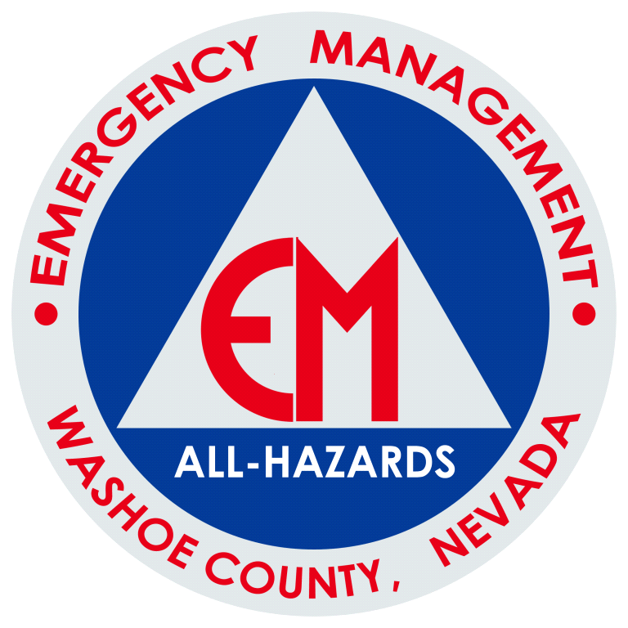

**SEPTEMBER**

Preparedness Month Activities

10 – Hazard Mitigation Exercise

17- PREPARE Washoe Meeting (Belfor Office)

25 – Alternate EOC & IAP Exercise (9th & Wells) (tentative)

**OCTOBER**

16 October ’14 LEPC

16 October ’14 Great Shake Out

**NOVEMBER**

17-20 November ’14 – IEMC Emmitsburg, MD

**DECEMBER**

17 – December PREPARE Washoe

18 December ’14 - LEPC

**Future Year FFY- 2015**

March 19 ’15 – UNR Exercise that may include a hazardous materials component

**9. UPDATE FROM THE RADIOLOGICAL TASK FORCE** (Non-action item) – *A briefing on current radiological issues within the region.*

Chair Kenneston commented that he had discussed issue with Scott Alquist a number of times, including the fire in Carlsbad as well as activities at Yucca Mountain and how those activities affect radiological waste transport within Washoe County. Chair Kenneston noted that he would seek a full update from Mr. Alquist at the next meeting.

**10. UPDATE OF CITIZEN CORPS** (Non-action item) – *A briefing on events and activities supported by the Washoe County Citizen Corps including, but not limited to, Community Emergency Response Teams (CERT).*

Shirlee Rhodes – CERT (Community Emergency Response Team), commented that CERT volunteers had participated in the “Take Control Project” providing safety information at several park trailheads during the summer. Ms. Rhodes noted that CERT is preparing for the upcoming Balloon and Reno Air Race events over the next ten (10) days.

Tim O’Conner – Washoe County Sheriff’s Office commented that Ms. Rhodes will assume responsibility as Program Director for the CERT program.

Chair Kenneston expressed his congratulations.

Chair Kenneston then noted that the final walk through for the Balloon Races is scheduled on September 2, 2014, at the Pagoda in Rancho San Rafael Park.

Chair Kenneston welcome former LEPC (Local Emergency Planning Committee) members Sandy Munns and Ed Atwell, who have joined the meeting to extend their congratulations to Chris Magenheimer on his retirement.

Ed Atwell suggested that Mr. Magenheimer not go back to work once retired.

Sandy Munns commented that after a year of retirement he is ready to go back to work.

**7. OFFICER ELECTIONS (**For possible action) – *Approval of nominations and vote for annual LEPC (Local Emergency Planning Committee) Officer positions; Nominees to make brief presentation on LEPC contribution.* [Reopened]

Cathy Ludwig – Grants Administrator, announced that Darryl Cleveland had been elected Vice-chair and Tim Spencer elected as the At-Large member.

Chair Kenneston congratulated the newly elected officers.

**11.****LEPC (Local Emergency Planning Committee) PRESENTATION** (Non-action item)– Update of status of TRIAD Hazmat Strategic Plan

Chair Kenneston recalled previous discussion after the TRIAD HazMat Strategic Plan had been adopted that voiced concerns about the need to update the Commodities Flow Study.  That process has been undertaken by ERRG, Inc who was the successful bidder.

Chris Curatilo - Engineering/Remediation Resource Group, Inc., narrated a PowerPoint presentation (copy on file) and explained that the final plan will be concise and cut back on recitations of regulations and certain other extraneous information.  The intent is to focus on goals, objectives and action items moving forward.  Mr. Curatilo noted that the region’s TRIAD HMRT appeared to be a grass roots process but could easily be on its way to setting the Gold Standard in the country but will need additional support from above to maintain proficiency and readiness.  The introduction of the proposed plan provides an overview of the role the TRIAD plays in the community, its mission and vision.  Mr. Curatilo outlined his process which was to work backwards from the desired end state.  It also included meeting and discussing the role and interaction with other hazmat first responder organizations in the region.  Mr. Curatilo noted that the final plan will also include a summary of the process that lead to the final document and an action plan to achieve the overarching goals.   Mr. Curatilo outlined the major goals set forth thus far and the need to identify funding sources for a proactive outreach program to attain those goals.

Chair Kenneston noted that copies of the Commodity Flow Study are available and emphasized the intent to align the plan with TRIAD needs.

**12.****LEPC (Local Emergency Planning Committee) PRESENTATION** (Non-action item)– *Briefing on the State and Local Implementation Grant Program (SLIGP), FirstNet, and other communications issues.*

George Molnar - Nevada Statewide Interoperable Communications Coordinator, provided a brief story on communications that is based on his father’s experience in protecting President John F. Kennedy in 1963 Texas. At the time radios were nearly non-existent and his father had only a whistle and a baton to seek assistance. Drawing attention to the number of smartphones and other data streaming devices, Mr. Molnar explained how communications had changed since 1963. The intent of FirstNet is to develop a nationwide communications/data network that provides a robust network for all public safety and first responders nationwide. Mr. Molnar then outlined the opt-in, which allows FirstNet to deploy the technology within the state, while Opt-out allows FirstNet to provide service but the state will provide the necessary infrastructure. Mr. Molnar challenged those present to participate in the process to assure that the system provides the necessary features to meet the needs of interoperability on a statewide basis. Mr. Molnar noted that $7-billion had been allocated for the project, which is insufficient to meet the needs of the nationwide project. Mr. Molnar emphasized that while the future system may ultimately provide head-up visuals, monitoring of life signs and breathing apparatus as well as notifications of officers hit by bullets or other injury to be recognized, it will not replace voice communications. Mr. Molnar noted that there is an 18-member Statewide Commission in place and noted that additional detail can be found at [www.firstnet.gov](http://www.firstnet.gove) and brochures available in the lobby.

Dee Grimm expressed her congratulations to Chris Magenheimer on his retirement and noted that it will be difficult to replace him.

**13. LEPC (Local Emergency Planning Committee) OFFICER, ALTERNATE AND/OR MEMBER ANNOUNCEMENTS, REQUESTS FOR INFORMATION AND SELECTION OF TOPICS FOR FUTURE AGENDAS** (Non-action item) - No discussion among committee members will take place on this item.*The next regular meeting is scheduled at 9:00 a.m. October 16, 2014.*

The next meeting is scheduled on October 16, 2014. No new agenda items were identified,

**14.** **PUBLIC COMMENT** (Non-action item)

Chair Kenneston noted that a wide range of topics had been covered in today’s (August 28, 2014) meeting and noted that a Federal Appeals Court has determined that the licensing of the Yucca Mountain facility must be completed. Chair Kenneston noted that Scott Alquist will provide a more complete update at the October 16, 2014, meeting.

Robb Kelly – CSD (Community Services Department), noted that the Washoe County Department of Water Resources had been merged into what is now known as CSD, and includes roads, community development as well as water resources.

**15. ADJOURNMENT**

Chair Kenneston adjourned the meeting at 10:13 a.m.